Lapeer Seafood Market to open in the Alpharetta City Center in November
Expect line-caught fish in a “bohemian-chic” atmosphere
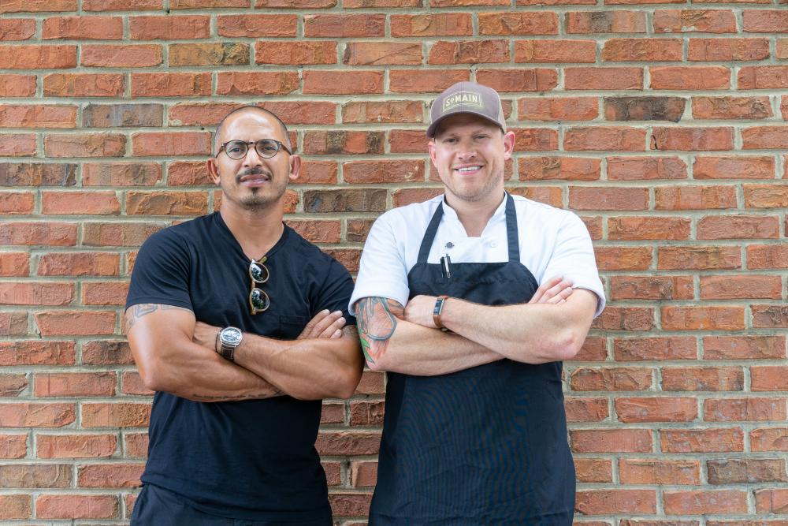
By: Carly Cooper - July 2, 2018

Lapeer owner Louis Soon (left) with executive chef Andy Long
PHOTO BY ASH WILSON
South Main Kitchen and Butcher & Brew proprietor Louis Soon’s next project is a high-end fish restaurant called Lapeer Seafood Market. Scheduled to open in the Alpharetta City Center in November, it will serve a daily-changing menu of raw items, plated entrees, and family meals, created by executive chef Andy Long.
The focus is seasonal, line-caught fish from around the country. “It’s bringing fresh seafood and farm to table together with Andy’s twist on it,” Soon says. “His philosophy is simple, clean, and approachable with super high-quality ingredients.”
The pair traveled to Charleston, New Orleans, and Montauk for inspiration. As a result, the menu will feature raw and baked oysters, sashimi, poke, soup, salad, entrees, and a daily special. Options may include spaghetti a la chitara with butter-poached lobster and sturgeon caviar, warm buttered lobster roll, and whole fried snapper with salsa verde. Three or four family-style mains, such as whole grilled trout with charred oranges, mint, and olive oil; roasted porchetta with crispy potatoes; and porterhouse with charred baby sweet potatoes and Asher blue cheese, will be available.
Cody Brown, currently of South Main Kitchen, will be behind the bar, serving a selection of cocktails made with fresh juice, local and coastal beers, and unique red and white wines. “Good wine is good wine. It doesn’t matter where you get it from,” Soon says, noting that the varietals will stem from all over. There will also be a section of mezcal drinks.
The space will seat between 125 and 140 guests and feature a temperature-controlled, glassed-in solarium that Soon describes as “like eating in a greenhouse.” There will be a teak bar, cocktail area with marble tabletops, and an open kitchen. Everything will be white, modern, and clean with a “bohemian-chic vibe,” Soon says.
He’s also working on a taco stand called Tocayo and a second Butcher & Brew, set to open in HALYCON in March 2019.

